Special Diets and Vegetarian
- What if my child has a special diet? If your child has dietary requirements this needs to be authorised by our Twelve15 catering company before we can serve them a school meal. Please contact the school office for more details if you believe your child needs this.
- Who can choose the “special diet” menu? Only children whose parents have an authorised special diet from Twelve15 can use this. If you are unsure about this please contact the school office and we can clarify.
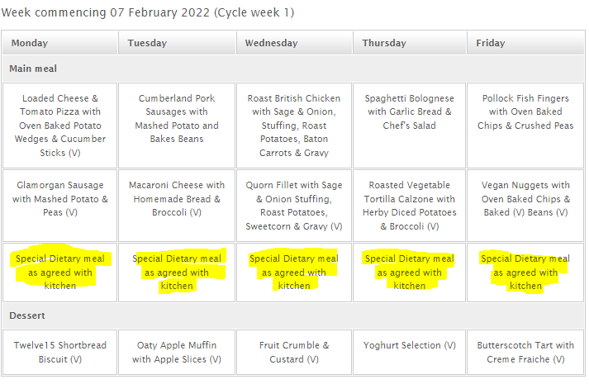
Children who have a special diet agreed with our catering company should ONLY click this option for their meals. DO NOT CLICK ON OTHER OPTIONS.
Note: please do NOT select this option if your child has no dietary requirements

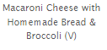
If your child is a vegetarian, only choose an option with a (V) next to it

